Design Doc – Connect – N

## Introduction

### Scope

The general idea of the project is to give the user the option to play and compete on a connect-N game with a board.

## Software design description

### General flow

The user enters the program, chooses N for the game, chooses his name and the opponent chooses his name also.

The first player chooses a column to place a disc on the board, then the disc is placed at the bottom of that column on the board. Now is the second player's turn.

And so on until one of them reaches a sequence of N discs and wins!

### Software architecture

The limitation on N is not larger than 8 when the play becomes impossible at some point.

N has a minimum of 4.

The architecture includes 3 main classes: Player, Game, and Display.

The Display is responsible for everything displayed on the board and can be managed independently (meaning there can be a different game view if it is implemented again differently).

The Player is responsible for everything the player is or does.

The Game is responsible for the board (of the size of the screen, TBD how many columns are on a board), the logic of the game – did anyone win? Is there a draw? And of course, making moves.

These can be viewed in this UML diagram:

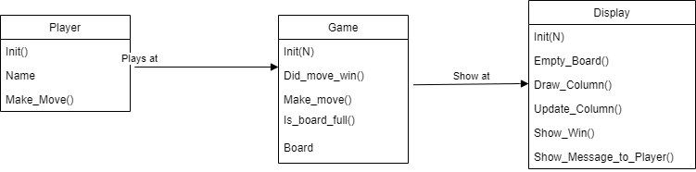

### User interface

Example screen

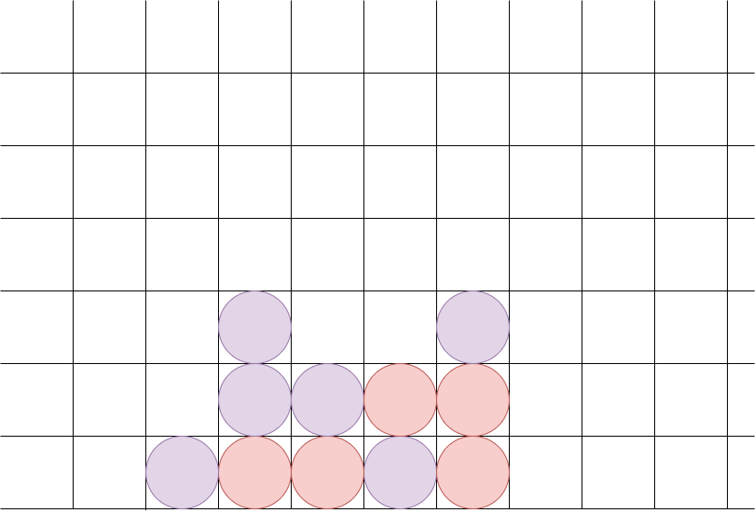

The screen shows 2 opponents, red and purple, on the board with what can be connect-4 because no side has won yet. (but it can be connect-5, connect-6… connect-8 as well).

### Data Handling

The program does not save large amounts of data since it doesn't have it. The board size is the biggest data saved and it is saved in a double array in the Game class.

There are no best scores since this is a game for 2 and no way to rate the games over each other.

## Tests and Monitor

### Tests

There will be a test that checks that a disc has been put in a specific column.

There will be a test that checks that after exactly N discs in a row the game shows winner to the right player. The test will check if this works in 1 row, in 1 column, and in both diagonals.

### Logs

There will be a log for choosing N.

There will be logs for players' names.

There will be logs for putting each disc in place.

There will be a log for an illegal move (putting a disc on a full column).

There will be a log for winning the game.

### Alerts

There won't be any alerts in the game.